**Assignment: SQL Notebook for Peer Assignment**

Estimated time needed: **60** minutes.

**Introduction**

Using this Python notebook you will:

1. Understand the Spacex DataSet
2. Load the dataset into the corresponding table in a Db2 database
3. Execute SQL queries to answer assignment questions

**Overview of the DataSet**

SpaceX has gained worldwide attention for a series of historic milestones.

It is the only private company ever to return a spacecraft from low-earth orbit, which it first accomplished in December 2010. SpaceX advertises Falcon 9 rocket launches on its website with a cost of 62 million dollars wheras other providers cost upward of 165 million dollars each, much of the savings is because Space X can reuse the first stage.

Therefore if we can determine if the first stage will land, we can determine the cost of a launch.

This information can be used if an alternate company wants to bid against SpaceX for a rocket launch.

This dataset includes a record for each payload carried during a SpaceX mission into outer space.

**Download the datasets**

This assignment requires you to load the spacex dataset.

In many cases the dataset to be analyzed is available as a .CSV (comma separated values) file, perhaps on the internet. Click on the link below to download and save the dataset (.CSV file):

[Spacex DataSet](https://cf-courses-data.s3.us.cloud-object-storage.appdomain.cloud/IBM-DS0321EN-SkillsNetwork/labs/module_2/data/Spacex.csv?utm_medium=Exinfluencer&utm_source=Exinfluencer&utm_content=000026UJ&utm_term=10006555&utm_id=NA-SkillsNetwork-Channel-SkillsNetworkCoursesIBMDS0321ENSkillsNetwork26802033-2022-01-01)

**Navigate to the Go to UI screen**

* Refer to this insruction in this [link](https://cf-courses-data.s3.us.cloud-object-storage.appdomain.cloud/IBMDeveloperSkillsNetwork-DB0201EN-SkillsNetwork/labs/Labs_Coursera_V5/labs/Lab%20-%20Sign%20up%20for%20IBM%20Cloud%20-%20Create%20Db2%20service%20instance%20-%20Get%20started%20with%20the%20Db2%20console/instructional-labs.md.html?utm_medium=Exinfluencer&utm_source=Exinfluencer&utm_content=000026UJ&utm_term=10006555&utm_id=NA-SkillsNetwork-Channel-SkillsNetworkCoursesIBMDS0321ENSkillsNetwork26802033-2022-01-01) for viewing the Go to UI screen.
* Later click on **Data link(below SQL)** in the Go to UI screen and click on **Load Data** tab.
* Later browse for the downloaded spacex file.

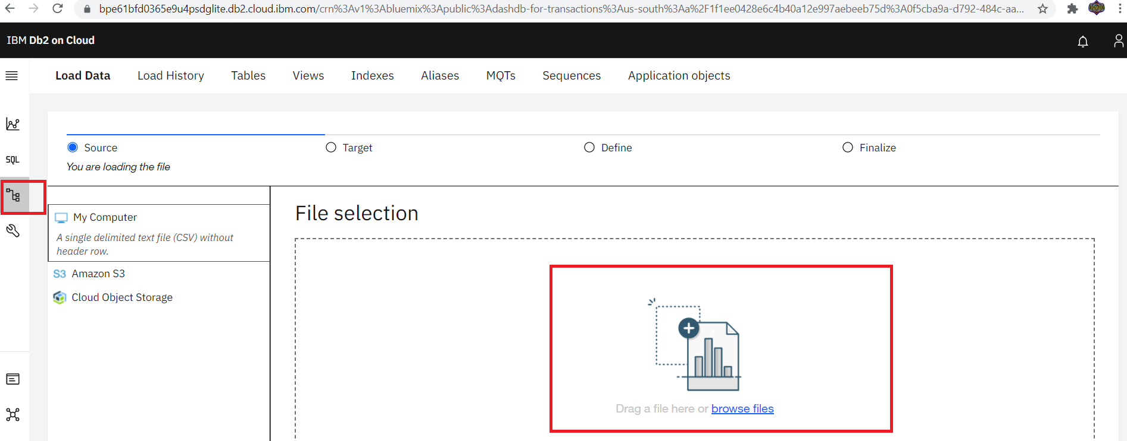

* Once done select the schema andload the file.

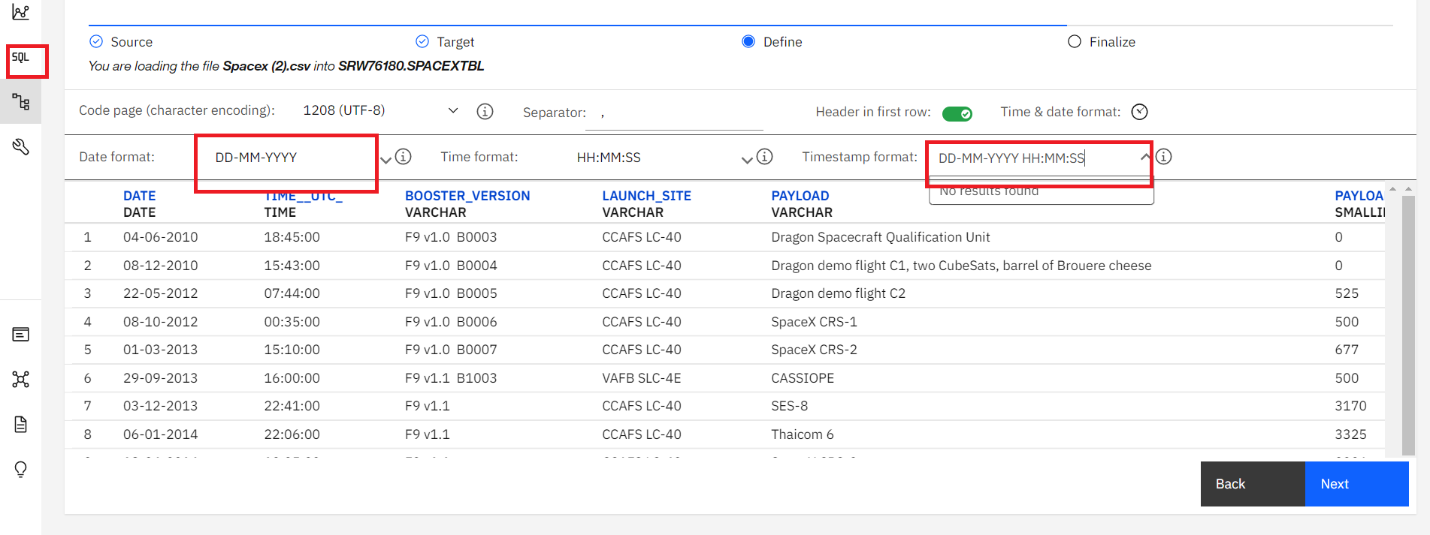

In [1]:

**!**pip install sqlalchemy**==**1.3.9

**!**pip install ibm_db_sa

**!**pip install ipython-sql